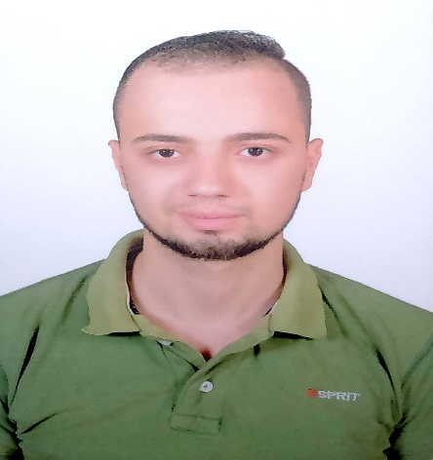
- Personal Information:
- Name: Mohamed Hosny Ali Mohamed
- Address: kafr saad - Damietta
- Nationality: Egyptian
- Marital status: Married
- Telephone: 02 0553752461
- Mobiles: 02 01062560519 / 02 01110825610
- E-Mails: mohamed.hosny@bhit.bu.edu.eg
melbkhomy@yahoo.com
––––––––––––––––––––––––––––––––––––––––––––––––––––––––––––––––––
- Education:
- Master Degree in Electrical Engineering (2017).
University: Benha - Egypt.
Thesis advisors: M.M. El Bahy (PI) and Wael A. Mohamed.
Thesis title: Simulation of A Control System Based on Human Brain Bio-signal Processing.
- Bachelor degree in Electrical Engineering (2012).
University: Benha - Egypt.
General Grade: Very Good.
Graduation Project Grade: Excellent.
––––––––––––––––––––––––––––––––––––––––––––––––––––––––––––––––––
- Job experiences:
- 2013 - 2016 - Demonstrator - Benha Faculty of Engineering, Electrical
Engineering Department, Biomedical Engineering.
- 2017- Lecturer Assistant - Benha Faculty of Engineering, Electrical
Engineering Department, Biomedical Engineering.
––––––––––––––––––––––––––––––––––––––––––––––––––––––––––––––––––
- Publications:
- M.M. El Bahy, M. Hosny, W.A. Mohamed, s. Ibrahim. EEG Signal Classification Using Neural Network and Support Vector Machine in Brain Computer Interface. Proceedings of the International Conference on Advanced Intelligent Systems and Informatics 2016. AISI 2016. Advances in Intelligent Systems and Computing, vol 533. Springer, Cham (2017)

